Unfortunately, this assignment requires you to have done the previous ones as it would not make sense otherwise. Make sure to have it completed before moving forward.

A rather short assignment this week:

* Implement a real time clock on the top-right corner of every frame which has a back button. It should look like in the picure:

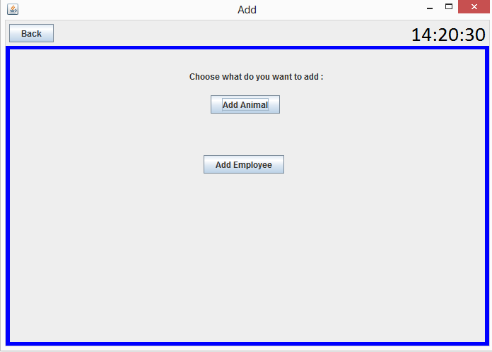

* It should run on a separate thread and not block the UI thread!
* By default, the timezone should be set to the timezone of the machine the program runs on. By clicking the clock however, a list of all Locales (timezones) should appear as a popup and by double-clicking on any of them, the clock should be updated to the new timezone.